Systematic evaluation of texts, documents and all kinds of media data.

QDA Miner Lite is a free and easy-to-use version of our popular computer assisted qualitative analysis software. It can be used for the analysis of textual data such as interview and news transcripts, open-ended responses, etc. as well as for the analysis of still images.

click the 􂀜New Project􂀝 button.
Four functions – four windows
1. Your data - import and organize your data in the Document System
2. Code your data - view, edit and categorize (code) your data in the Document
Browser
3. Your codes - organize your codes (categories) in the Code System
4. Display your coded data - search for and display certain 􂀜coded segments􂀝 (for
example, all data selections assigned with the the codes A, B and C in the
documents X, Y and Z) in the Retrieved Segments window.
new project - document -import tab-document.table,image,transcript,tweets. to select more than one item -hold down shift button -import done.also drag and drop into document system.
code and retrieve
organize- use doc group -put items there.-activate doc.ig you want data in more than one doc-doc sets.-select new set.
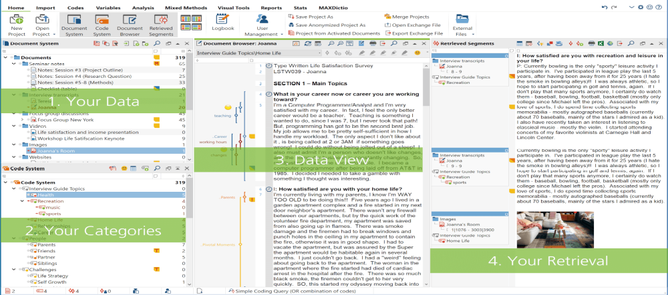

The "Document System"
Including text documents, tables, images, PDF documents or audio and video files.
Additionally, you can import results from (online) surveys, webpages, Twitter data,
transcriptions with timestamps or focus group transcripts in such a way that
information beyond the text is also recognized by MAXQDA and automatically
processed in the form of codes or variables.
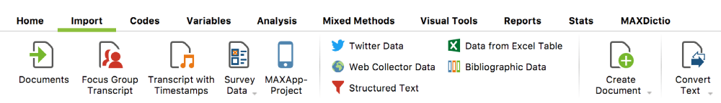
Importing your data via the 'Import' Tab
1. Your data – the "Document System"
Import
New project - document - "Import" tab and select” Import documents"

select the documents you would like to import. Alternatively, you can simply drag and
drop these files from Windows Explorer or Mac Finder into the "Document System"
window.

2. View, edit and code your data – the "Document Browser"

All texts, tables or images that you import into MAXQDA can be viewed here in the
Document Browser. (There is also a media player for audio and video files.) On the left
side of the page, you will see your coded segments, any memos you have written, and
any time stamps (for audio and video recordings).

